OOPs Introduction in JAVA

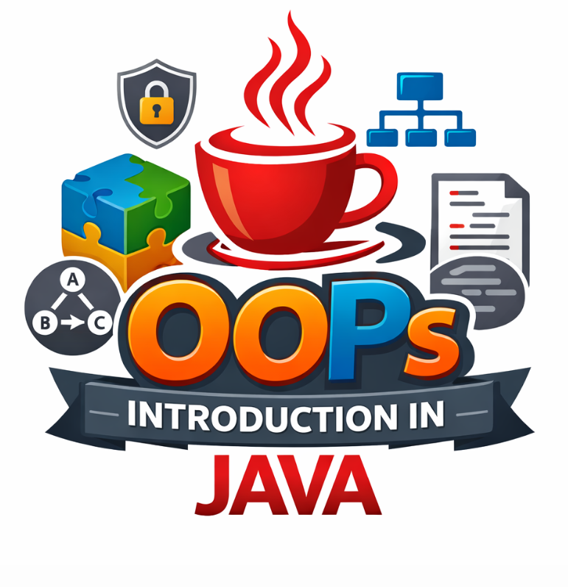
1. What is OOPs?
OOPs (Object-Oriented Programming System) is a programming paradigm based on the concept of objects.
In Java, everything revolves around objects and classes.
Simple Definition:
OOPs is a way of writing programs using objects and classes instead of just functions.

2. Why OOPs?
Before OOPs → Procedural Programming (C language style)
Problems:
- Code duplication
- Difficult to manage large projects
- No proper security

OOPs solves:
- Reusability
- Security
- Easy maintenance
- Real-world modeling

3. Real-Life Example of OOPs
Think of a Car
- Class → Car
- Object → BMW, Audi, Tesla
Properties:
- color
- speed
Behavior:
- start()
- stop()

4. Basic Concepts of OOPs
There are 4 main pillars:
- Encapsulation
- Inheritance
- Polymorphism
- Abstraction

5. Class in Java
Definition:
A class is a blueprint or template for creating objects.
Syntax:
class Student {
int id;
String name;
}

6. Object in Java
🔹 Definition:
An object is an instance of a class.
🔹 Syntax:
Student s1 = new Student();

7. Full Example (Class + Object)
class Student {
int id;
String name;
void display() {
System.out.println(id + " " + name);
}
}
public class Main {
public static void main(String[] args) {
Student s1 = new Student();
s1.id = 1;
s1.name = "Omii";
s1.display();
}
}

8. Constructor in Java
Definition:
A constructor is a special method used to initialize objects.
Example:
class Student {
int id;
String name;
Student(int i, String n) {
id = i;
name = n;
}
void display() {
System.out.println(id + " " + name);
}
}

9. Types of Constructors
- Default Constructor
- Parameterized Constructor

10. Encapsulation
Definition:
Wrapping data and methods into a single unit.
Achieved using:
- Private variables
- Public getter/setter methods
Example:
class Student {
private int id;
public void setId(int id) {
this.id = id;
}
public int getId() {
return id;
}
}

11. Inheritance
Definition:
One class acquires properties of another class.
Syntax:
class Animal {
void eat() {
System.out.println("Eating...");
}
}
class Dog extends Animal {
void bark() {
System.out.println("Barking...");
}
}

12. Types of Inheritance
- Single
- Multilevel
- Hierarchical
(Java does NOT support multiple inheritance with classes)

13. Polymorphism
Definition:
One method, multiple forms.
Types:
- Compile-time (Method Overloading)
- Runtime (Method Overriding)

Method Overloading Example:
class MathUtil {
int add(int a, int b) {
return a + b;
}
int add(int a, int b, int c) {
return a + b + c;
}
}

Method Overriding Example:
class Animal {
void sound() {
System.out.println("Animal sound");
}
}
class Dog extends Animal {
void sound() {
System.out.println("Dog barks");
}
}

14. Abstraction
Definition:
Hiding implementation details and showing only functionality.
Achieved using:
- Abstract classes
- Interfaces

Abstract Class Example:
abstract class Animal {
abstract void sound();
}
class Dog extends Animal {
void sound() {
System.out.println("Bark");
}
}

15. Interface in Java
interface Animal {
void sound();
}
class Dog implements Animal {
public void sound() {
System.out.println("Bark");
}
}

16. Difference: Class vs Object
Class | Object
Blueprint | Instance
Logical | Physical
No memory | Takes memory

17. Difference: Abstraction vs Encapsulation
Abstraction | Encapsulation
Hides implementation | Hides data
Abstract class/interface | Getter/Setter

18. Real-World Project Example
Employee System
class Employee {
int id;
String name;
double salary;
void display() {
System.out.println(id + " " + name + " " + salary);
}
}

19. Advantages of OOPs
✔ Code Reusability
✔ Security
✔ Easy Maintenance
✔ Modularity
✔ Flexibility

20. Disadvantages of OOPs
Complex for beginners
More memory usage
Slower than procedural

- Java supports OOPs fully except multiple inheritance (with classes)
- Everything in Java is object-based except primitives
- Constructor is not a method
- Method overriding → runtime polymorphism

21. Conclusion
OOPs is the heart of Java programming.
Without understanding OOPs, you cannot become a strong Java developer.

